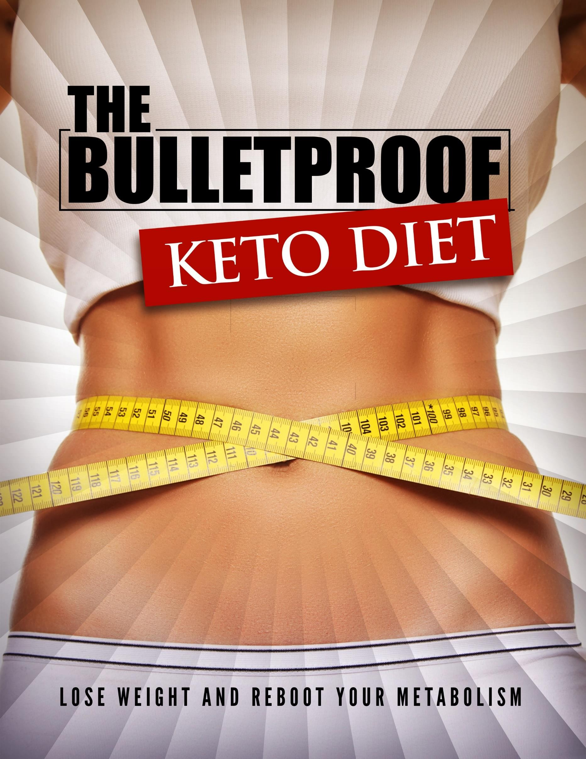

**Click Here to Access The “The Bulletproof Keto Diet” Video Course! (Insert URL)**

# The Bulletproof Keto Diet Cheat Sheet

Your Goal: Burn More Fat Passively By Eating FAT How? Use FAT as your body’s fuel instead of SUGAR

The OBJECTIVE: KETOSIS = Burning fat instead of sugar

Step 1: Resolve to Change your lifestyle instead of going on another diet

* Think long term
* Believe that the keto lifestyle works
* Believe that you can do it
* If other people can do it, you can do it too Step 2: Displace, Do Not Replace
* Add keto items to your diet
* Focus more on ketogenic meals

Step 3: Make the following Meal Plan Choices

* Focus on fatty food that fits your taste
* Shoot to feel fuller for a longer period of time
* Eventually cut out soda
* Eventually cut out grain-based snacks
* Slowly cut out milk-based snacks Step 4: Wind Down Carbs
* By this point, you have gotten used to eating keto foods
* Start to scale down your carb intake dramatically
* Eat more eggs
* Eat more avocado

Step 5: Step up Keto Weight Loss with the Following New Habits

* Eat only when you're hungry
* Drink first when you get hunger pangs
* Eat slowly
* Look at each of your meals as some sort of event
* Eat more mindfully

Step 6: Finetune your Keto Diet

* Start to regularize your meal times
* Eliminate or greatly reduce snacking
* Eventually scale down to one or two meals a day
* Scale down to one meal a day: intermittent fasting
* If you can, adopt a day-to-day fasting technique